# CIS7 Unit 11 Rev 1 In-Class Assignment: Graphs and Vertices

1. Refer to below graph and identify the following:
2. Vertices {A,B,C,D,E,F,G}
3. Edges {{A,B},{B,A},{A,C},{C,A},{A,E},{E,A},{C,D},{D,C},{C,F},{F,C},{E,G},{G,E},{F,E},{E,F}{G,F}{F,G},{B,G},{G,B},{E,D},{D,E},}
4. Degree of vertices A=E=F=4; C=G=3; B=D=2
5. Adjacent and non-adjacent vertices.

A ADJ. TO E,F,C,B

A NON-ADJ. TO G,D

B ADJ. TO A,G

B NON-ADJ. TO C,D,E,F

C ADJ. TO A,F,D

C NON-ADJ. TO A,B,E,F,G

D ADJ. TO E,B,G

D NON-ADJ. TO A,B,G,F

E ADJ. TO A,F,G,D

E NON-ADJ. TO B,C

F ADJ. TO E,G,C

F NON-ADJ. TO D,A,B

G ADJ. TO B,E,F

G NON-ADJ. TO C,D,A

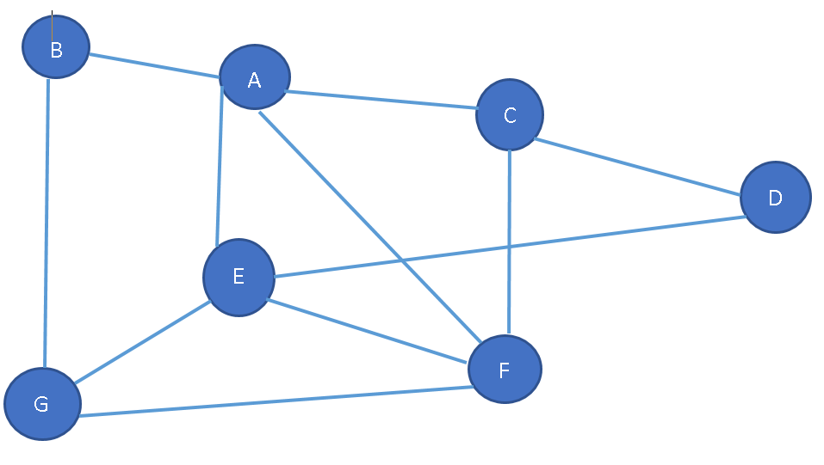

1. Refer to Exercise 1 graph, note the degrees of vertices in the graph.

A=F=4; E=G=C=3; D=B=2

1. Refer to Exercise 1 graph, identify the paths of each vertex in the graph.

SIMPLE: (B,G),(B,A,E,G),(A,E,F,C,D),(A,C,D,E,G),(C,F,E,A,B)

CYCLE:(B,G,E,D,A,B),(A,C,D,E,A),(E,F,G,E)

1. Refer to below graph, and identify the following:
2. Vertices {A,B,C,D,E,F,G}
3. Edges {{B,A},{A,E},{B,G},{A,G},{A,F}{E,F}{E,G},{C,D}}
4. Degree of the vertices A=G=4; E=F=3; B=2; {C,D}1
5. Adjacent and non-adjacent vertices

A ADJ. TO B,E,F,G

A NON-ADJ. TO C,D

B ADJ. TO A,G

B NON-ADJ. TO C,D,E,F

C ADJ. TO D

C NON-ADJ. TO A,B,E,F,G

D ADJ. TO C

D NON-ADJ. TO A,B,G,E,F

E ADJ. TO A,F,G

E NON-ADJ. TO B,C,D

F ADJ. TO B,C,D

F NON-ADJ. TO B,C,D

G ADJ. TO B,E,F,A

G NON-ADJ. TO C,D

1. Degrees of vertices A=G=4; F=E=3; B=3 D=C=1
2. Paths, no path and simple paths.

SIMPLE: (B,A,F,E,G), (C,D), (G,E,F)..

CYCLE: (B,A,F,E,G,B),(A,G,E,F,A),(E,G,F,E)

NO PATH: (C,A-F),(D,A-F) !=(C,D),(D,C)

LONG: (B,A,G,E,G,A,E,F)

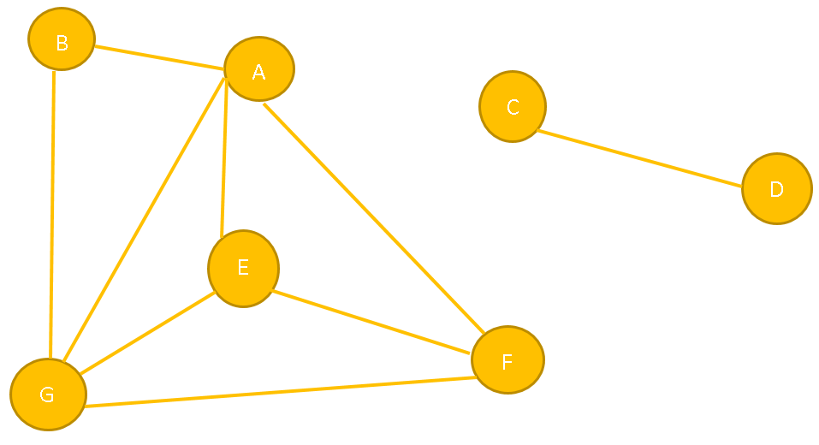

1. Refer to below graph and identify the cycles in the graph (yellow paths).
   1. Vertices {A,B,C,D,E,F,G}
   2. Edges {{A,B},{A,E},{A,G},{B,G},{E,G},{E,F},{F,A},{C,F},{C,D},{F,D},{F,G}}
   3. Degree of the vertices A=G=4; F=E=3 D=B=2
   4. Adjacent and non-adjacent vertices

A ADJ. TO B,E,F

A NON-ADJ. TO C,D,G

B ADJ. TO A,G,G

B NON-ADJ. TO C,D,F

C ADJ. TO D,F

C NON-ADJ. TO A,B,E,G

D ADJ. TO C,F

D NON-ADJ. TO A,B,G,E

E ADJ. TO A,F,G

E NON-ADJ. TO B,C,D

F ADJ. TO G,C,D

F NON-ADJ. TO B,A,F

G ADJ. TO B,E,F

G NON-ADJ. TO C,D,A

* 1. Degrees of vertices A=G=4; F=E=3 D=B=2
  2. Paths, no path and simple paths.

SIMPLE: (B,A,F,E,G), (C,D), (G,E,F)..

NO PATH: (F,E) (G,E) (E,A) (B,A) (F,C) (A,F) (D,F) (D,C)

* 1. Cycles

(A,B,G,A) (A,E,G,A) (A,E,F,A) (F,A,G,F)

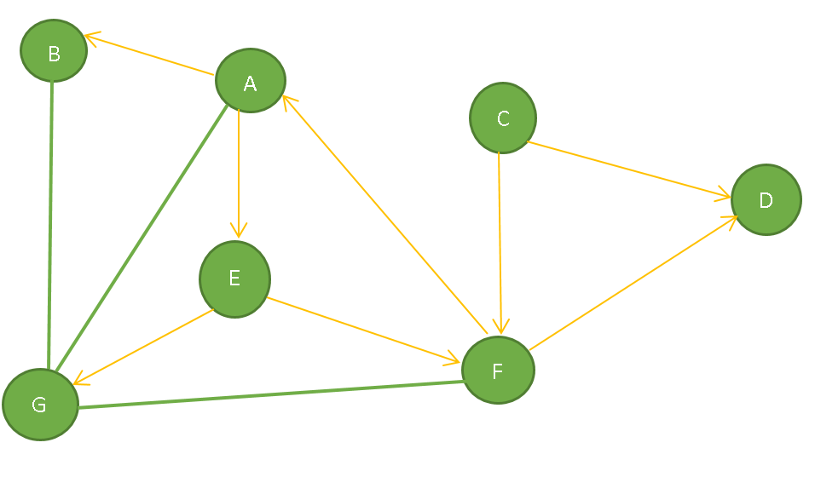

1. Refer to below simple graph and create its adjacency list.

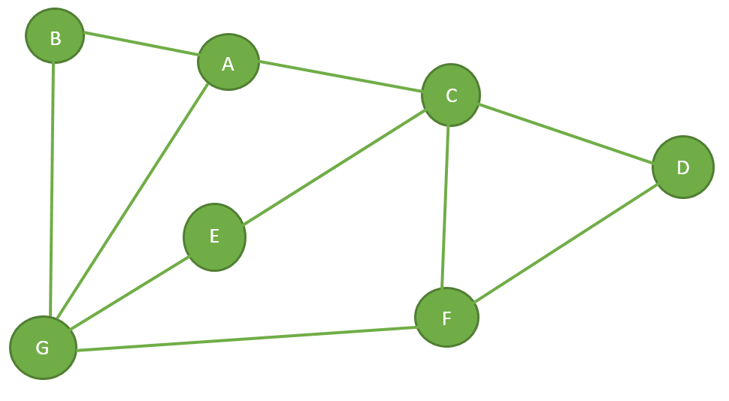

|  |  |  |  |  |  |  |  |
| --- | --- | --- | --- | --- | --- | --- | --- |
| V | A | B | C | D | E | F | G |
| A | 0 | 1 | 1 | 0 | 0 | 1 | 1 |
| B | 1 | 0 | 0 | 0 | 0 | 0 | 1 |
| C | 1 | 0 | 0 | 1 | 1 | 1 | 0 |
| D | 0 | 0 | 1 | 0 | 0 | 1 | 0 |
| E | 0 | 0 | 1 | 0 | 0 | 0 | 1 |
| F | 0 | 0 | 1 | 1 | 0 | 0 | 1 |
| G | 1 | 1 | 0 | 0 | 1 | 1 | 0 |

1. Refer to below weighted graph and determine its adjacency list.

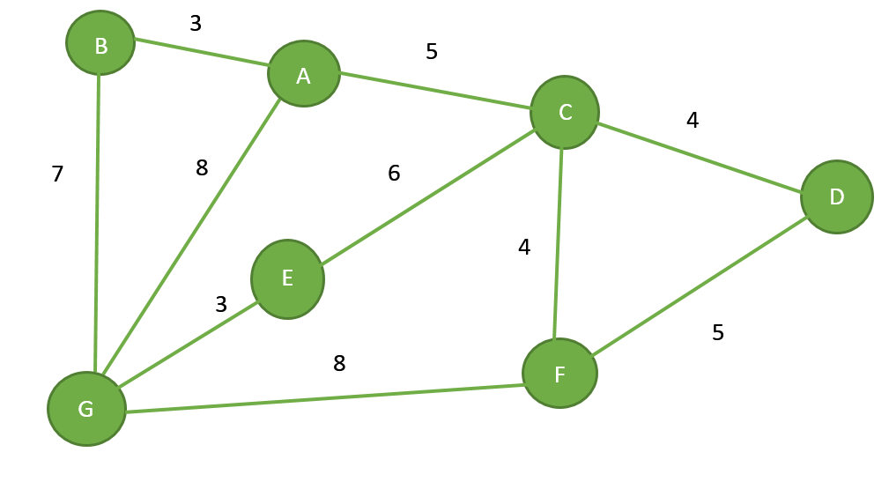

|  |  |  |  |  |  |  |  |
| --- | --- | --- | --- | --- | --- | --- | --- |
| V | A | B | C | D | E | F | G |
| A | 0 | 3 | 5 | 0 | 0 | 0 | 8 |
| B | 3 | 0 | 0 | 0 | 0 | 0 | 7 |
| C | 5 | 0 | 0 | 4 | 6 | 4 | 0 |
| D | 0 | 0 | 4 | 0 | 0 | 5 | 0 |
| E | 0 | 0 | 6 | 0 | 0 | 0 | 3 |
| F | 0 | 0 | 4 | 5 | 0 | 0 | 8 |
| G | 8 | 7 | 0 | 0 | 3 | 8 | 0 |

1. Create the adjacency matrix based on the below graph.

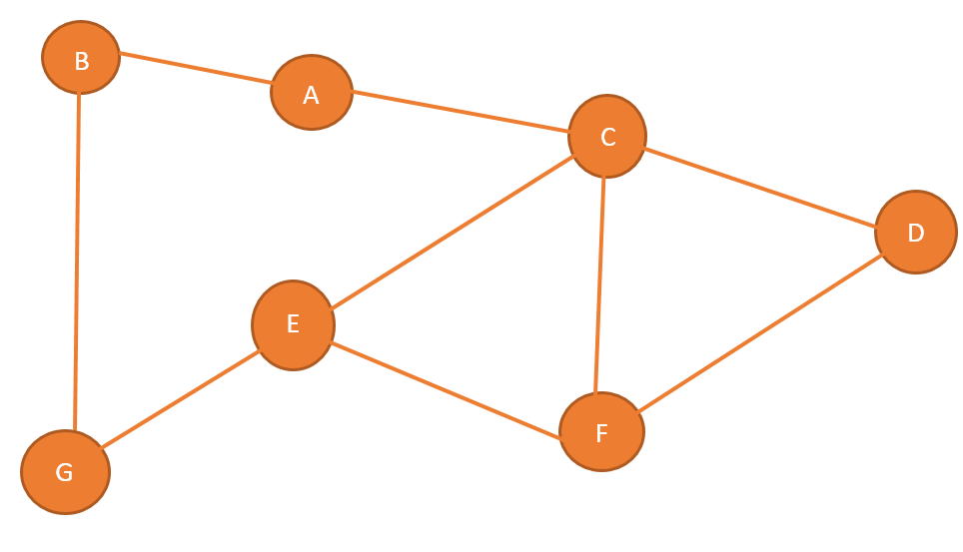

|  |  |  |  |  |  |  |  |
| --- | --- | --- | --- | --- | --- | --- | --- |
| V | A | B | C | D | E | F | G |
| A | 0 | 1 | 1 | 0 | 0 | 0 | 0 |
| B | 1 | 0 | 0 | 0 | 0 | 0 | 1 |
| C | 1 | 0 | 0 | 1 | 1 | 1 | 0 |
| D | 0 | 0 | 1 | 0 | 0 | 1 | 0 |
| E | 0 | 0 | 1 | 0 | 0 | 1 | 1 |
| F | 0 | 0 | 1 | 1 | 1 | 0 | 1 |
| G | 0 | 1 | 0 | 0 | 1 | 0 | 0 |

1. Create adjacency matrix based on the below weighted graph.

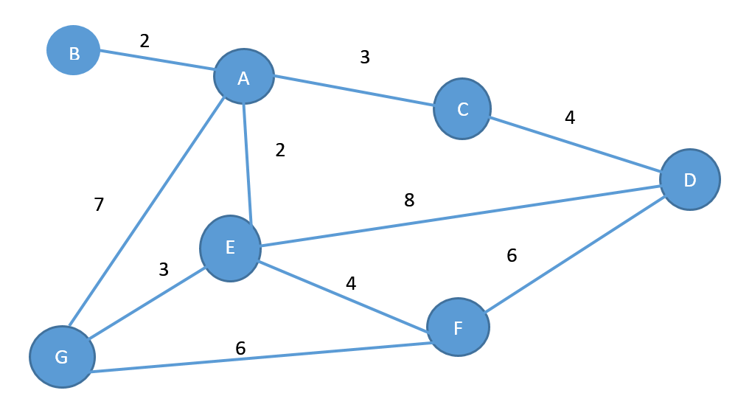

|  |  |  |  |  |  |  |  |
| --- | --- | --- | --- | --- | --- | --- | --- |
| V | A | B | C | D | E | F | G |
| A | 0 | 2 | 3 | 0 | 2 | 0 | 7 |
| B | 2 | 0 | 0 | 0 | 0 | 0 | 0 |
| C | 3 | 0 | 0 | 4 | 0 | 0 | 0 |
| D | 0 | 0 | 4 | 0 | 0 | 6 | 0 |
| E | 2 | 0 | 1 | 8 | 0 | 4 | 3 |
| F | 0 | 0 | 0 | 6 | 4 | 0 | 6 |
| G | 7 | 0 | 0 | 0 | 3 | 6 | 0 |

1. Identify the depth first traversal paths based on the node’s adjacency list using the below graph.

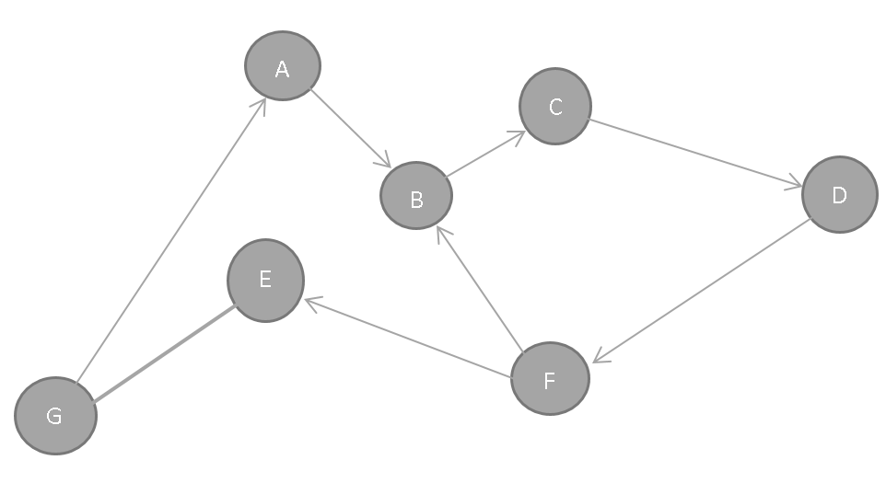

DFTP: (G,A,B,C,D,F,E), OR (G,E)

1. Using the below graph, complete the following tasks:
   1. Illustrate the breadth first traversal starting at vertex F. (F,E,B,C,D,)
   2. Illustrate any path in the graph. (F,B,C,D)
   3. Demonstrate the use of shortest path (F,B,C,D)

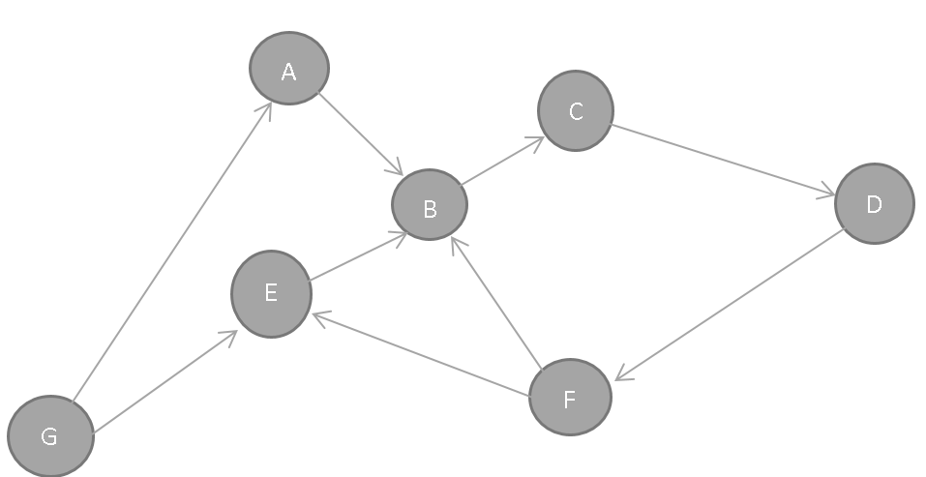

1. Determine the cheapest path for the below graph.

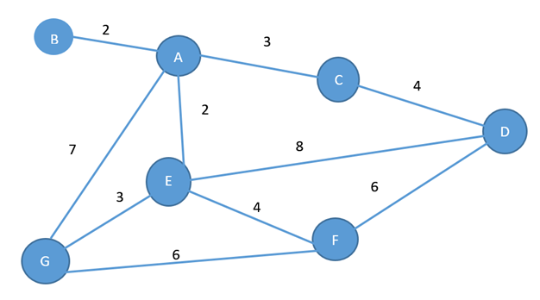

CHEAPEST PATH:

2+3+4= 9

2+2+4=8 (F,E,A,B)

2+7? (TOO BIG)

~~2+2+8~~